# Exam 2024

Indholdsfortegnelse

Exam 2024 1

Topic 1 4

( 15 % ). Show steps 4

( 60 % ). Perform 5

( 15 % ). Evalutate if it’s converging 5

( 10 % ). Explain why an iterative approach, EM is required to find the GMM. 5

Topic 2. Probabilistic generative classification model. 6

( 50 % ) Maximum likelihood approach to figure out 6

( 15 % ). Use that to compute the posterior function 6

( 25 % ). Estimate and plot the decision boundary. Now which classes does the test points belong to. 6

Topic 3 6

( 10 % ) Fisher linear discriminant 6

( 10 % ) Logistic regression 6

( 10 % ) Linear support vector machines SVM. 6

( 20 % ) Fisher linear discriminant, doable with nonlinear transformation. 7

( 20 % ) After the transformation, plot the 1D datapoints and the corresponding decision boundary. 7

( 20 % ) Kernel and SVM’s 7

(10 % ) Given test data and kernel SVM what will the classification be? 7

Topic 4 7

( 15 % ) Given what’s y? Show calculations. 7

( 15 % ) Assuming given from data , what the CEE function if 8

( 40 % ) Back propagation, partial derivatives of 8

( 15 % ) Solved for , how will I update the weights? ( 15 % ) How can this network output be used for binary classification?. 9

11](#_Toc187402576)

## Topic 1

Given a dataset x  
Which is assumed to be made of two gaussian mixed models. GMM’s.   
Estimate the mean values with the expectation maximization method. EM.



### Et billede, der indeholder Font/skrifttype, tekst, håndskrift, hvid Automatisk genereret beskrivelse( 15 % ). Show steps

I will evaluate the responsibilities. This will later be used as a normalization factor and more.

Then reestimating the parameters.

Then I will evaluate the log likelihood to see if it has converged. Typically a threshold will be set in code, for the calculation to stop.

### ( 60 % ). Perform

, that can’t be right. But the means looks to be okay.

### ( 15 % ). Evalutate if it’s converging

From how the mean turned out, it appears as if it’s almost converged as  
   
   
Well it appears, that it already has converged from that.   
I guess the standard deviation is too, but I might have made a typo somewhere.

### ( 10 % ). Explain why an iterative approach, EM is required to find the GMM.

## Topic 2. Probabilistic generative classification model.

### ( 50 % ) Maximum likelihood approach to figure out

It’s a case of the previous question, but now with multivariate data. I’ve previously solved for these scenarios, and I will leave the code in my ipynb file that I will attach. If I don’t managed to get a result, I haven’t input the data to be of the right format.

### ( 15 % ). Use that to compute the posterior function

### ( 25 % ). Estimate and plot the decision boundary. Now which classes does the test points belong to.

## Topic 3

Given a data plot of circular classification can I classify it with:

### ( 10 % ) Fisher linear discriminant

### ( 10 % ) Logistic regression

### ( 10 % ) Linear support vector machines SVM.

Now there exist a nonlinear transformation that makes

### ( 20 % ) Fisher linear discriminant, doable with nonlinear transformation.

### ( 20 % ) After the transformation, plot the 1D datapoints and the corresponding decision boundary.

### ( 20 % ) Kernel and SVM’s

### (10 % ) Given test data and kernel SVM what will the classification be?

## Topic 4

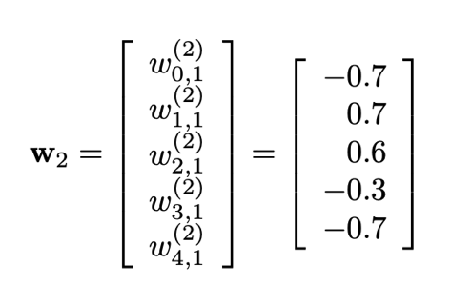Given a neural network of shape, and with weights:   
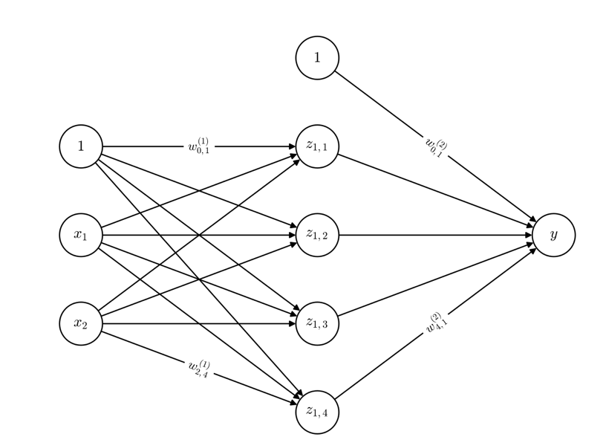‘’’

With activation functions.

### ( 15 % ) Given what’s y? Show calculations.

I will be doing this in python.

Giving me all the values of z.   
   
Then   
   
Will give me the values of y.

### Et billede, der indeholder Font/skrifttype, tekst, hvid, kalligrafi Automatisk genereret beskrivelse( 15 % ) Assuming given from data , what the CEE function if

Normal error function is given from  
   
Which is low in my opinion. But as it’s the cross entropy function I think I might have to make it in terms of log, as I’m reading on the internet. I found this one in neural network training section, that will be the right one.

=============================  
   
=============================

### Et billede, der indeholder linje/række, cirkel, diagram, Font/skrifttype Automatisk genereret beskrivelse( 40 % ) Back propagation, partial derivatives of



This doesn’t make to much sense, as I should calculate w4,1 as well just to calculate the first layer weight… Might be a mistake, but might not. I will then calculate for 3 derivatives.   
They all share same activation function.

Now for the next.   
I have to know of   
   
   
And that’s it.

================  
   
   
================

### ( 15 % ) Solved for , how will I update the weights? ( 15 % ) How can this network output be used for binary classification?.

As the activation function of the outputs is of sigmoid operations, depended on how the weights are, the slope of it can almost simulate infinity. If the network is constructed such that, two values going into the output are positive, and two of them is negative, while they are of same magnitude, they can cancel each other out. If spaced correctly, this could make step like behavior.

## Ipynb document Et billede, der indeholder tekst, skærmbillede, software, Multimediesoftware Automatisk genereret beskrivelseEt billede, der indeholder tekst, skærmbillede, software, Multimediesoftware Automatisk genereret beskrivelse

